
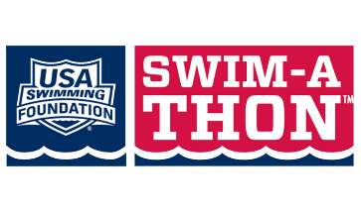
2025 Swim-A-Thon
Thank You Gifts
Amount Raised | Thank You Gift
$150 | Team t-shirt
$300  Choice of: | 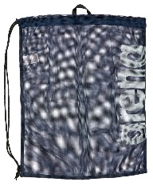    PPSC mesh gear bag
$300  Choice of: | 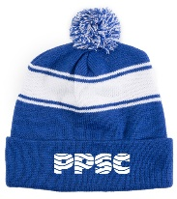  PPSC winter hat
$600  Choice of: | 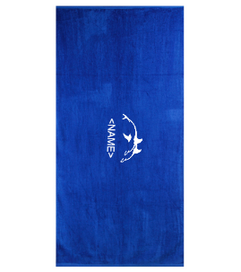  PPSC Towel with Name
$600  Choice of: | 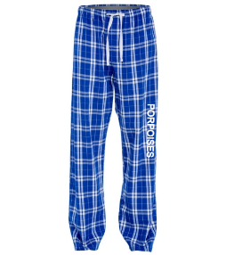  PPSC PJs (Adult size)
$600  Choice of: | 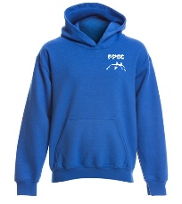  PPSC Sweatshirt (Youth size)
$1,200  Choice of: | 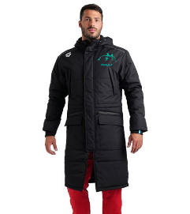  PPSC Parka with name
$1,200  Choice of: | 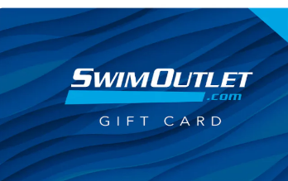  $250 Swim Outlet gift certificate
$1,200  Choice of: | 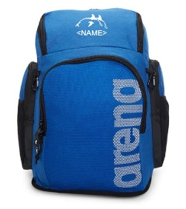  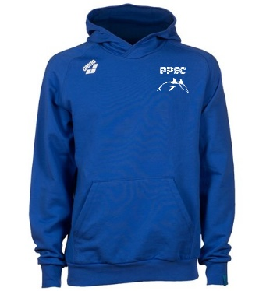  PPSC Swim Bag & Adult PPSC Sweatshirt (blue or white)

